

**Bharati Vidyapeeth**

**(Deemed to be University)**

**College of Engineering,**

**Pune – 411043**

**Academic Year: 2024-25**

**Department of Electronics & Communication Engineering**Project Based Learning Report

On

ONE TRANSISTOR PHASE SHIFT OSCILLATOR

Submitted in the partial fulfillment of the requirements for the project based learning in ANALOG CIRCUITS AND APPLICATIONS

In

Electronics & Communication Engineering

By

2314110480 Ayush Raj

2314110489 Anupriya Sakshi

2314110675 Shital Thapa

Under the guidance of

**Dr. Tanuja S. Dhope**

Department of Electronics & Communication Engineering

Bharati Vidyapeeth

(Deemed to be University)

College of Engineering,

Pune – 4110043

**Academic Year - 2024- 25**

**Bharati Vidyapeeth**

**(Deemed to be University)**

**College of Engineering**

**Pune – 411043**

**DEPARTMENT OF ELECTRONICS & COMMUNICATION ENGINEERING**

**CERTIFICATE**

Certified that the Project Based Learning report entitled, “ONE TRANSISTOR PHASE SHIFT OSCILLATOR” is work done by

**PRN Name of the Student**

**2314110480 Ayush Raj**

**2314110489 Anupriya Sakshi**

**2314110675 Shital Thapa**

in partial fulfillment of the requirements for the award of credits for Project Based Learning (PBL) in **“Analog circuits and applications”** of Bachelor of Technology Semester III, in Electronics and communication Engineering.

**DATE: 04.10.2024**

**Dr. Tanuja S. Dhope Dr.Arundhati Shinde**

**Course In-charge Professor & Head**

**ACKNOWLEDGMENT**

We would like to express my special thanks of my gratitude to my professor **“ Dr. Tanuja S. Dhope ”** for their able guidance and support in completing this project.

Then we would like to thank my parents and friends who helped me with their valuable suggestions and guidance has been helpful in various phases of the completion of the project.

**Ayush Raj**

**Anupriya Sakshi**

**Shital Thapa**

**INDEX**

|  |  |  |
| --- | --- | --- |
| **S.NO** | **TOPIC** | **PAGE NO.** |
| 1. | PROBLEM STATEMENT | 1 |
| 2. | INTRODUCTION | 2-4 |
| 3. | COMPONENTS REQUIRED | 5-6 |
| 4. | CALCULATION | 7-8 |
| 5. | CIRCUIT DIAGRAM & RESULT | 9-12 |
| 6. | OUTCOME | 13 |
| 7. | CONCLUSION | 14 |
| 8. | REFERENCE | 15 |

**Chapter 1**

**PROBLEM STATEMENT**

* **Implement one transistor phase shift oscillator.**
* Circuit design schematic.
* Calculations for component values to achieve the desired frequency.
* Simulation results showing stable oscillations.
* Physical implementation .
* Analysis of the performance of the oscillator, including frequency stability and waveform distortion.

**Chapter 2**

**INTRODUCTION**

An RC phase shift oscillator is a type of electronic oscillator that generates a sinusoidal output signal at a specific frequency using a combination of resistors (R) and capacitors (C). It is widely used in low-frequency applications and is known for its simplicity and stability. The key principle behind this oscillator is the phase shift produced by an RC network, which shifts the phase of the signal by 180 degrees. By using three or more stages of RC networks, a total phase shift of 180 degrees is achieved, which when combined with an additional 180-degree phase shift from an inverting amplifier (such as a transistor or an operational amplifier), results in a total phase shift of 360 degrees or 0 degrees, satisfying the Barkhausen criterion for sustained oscillations.

The frequency of oscillation depends on the values of the resistors and capacitors used, and the design is typically chosen to be easy to implement with common components. This type of oscillator is particularly suitable for audio frequency generation and low-power applications, though it is generally limited to lower frequencies compared to other types of oscillators like LC or crystal oscillators.

**Key Features:**

* Uses resistors and capacitors to produce a phase shift.
* Achieves oscillation by satisfying the Barkhausen criterion.
* Suitable for generating low-frequency signals.
* Typically involves a single amplifier stage with a feedback network.

**Working Principle**

The RC phase shift oscillator works by exploiting the **Barkhausen criterion** for oscillation, which states that for sustained oscillations in any feedback system, the total loop gain must be at least 1, and the total phase shift around the loop must be 360 degrees (or 0 degrees, depending on perspective). In the case of the RC phase shift oscillator, this total phase shift is achieved through the combination of an inverting amplifier, which contributes a 180-degree phase shift, and an RC feedback network, which adds another 180-degree phase shift across multiple stages.

In a typical RC phase shift oscillator, the amplifier can be implemented using a transistor or an operational amplifier. The feedback network consists of three or more RC stages, each providing a phase shift of approximately 60 degrees, so that the total phase shift through the feedback path sums to 180 degrees. When the feedback signal is fed back to the input of the inverting amplifier, the signal undergoes another 180-degree phase shift, resulting in the required total phase shift of 360 degrees (or 0 degrees), which ensures that the oscillations are in phase with the original input signal.

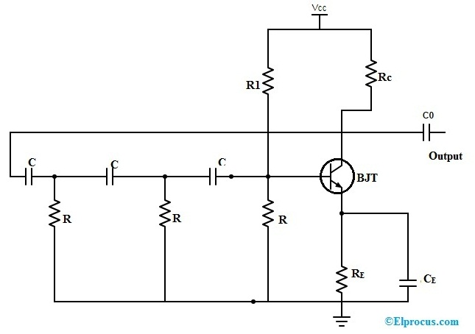

**Frequency Formula:**

fr **= $\frac{1}{2πRC√2N }$**

**Advantages of RC Phase Shift Oscillators**

1. **Simplicity**: The RC phase shift oscillator is relatively simple to design and implement, requiring only basic components such as resistors, capacitors, and a single amplifier.
2. **Low Frequency Operation**: It is particularly well-suited for generating low-frequency signals, making it ideal for audio applications, function generators, and instrumentation.
3. **Stability**: The frequency of oscillation is stable as long as the component values (resistors and capacitors) remain constant. Additionally, since the frequency is determined solely by the RC network, the oscillator does not require inductors, which are typically more bulky and expensive.
4. **Cost-Effective**: The oscillator uses inexpensive and widely available components, making it a cost-effective solution for many practical applications.

**Disadvantages of RC Phase Shift Oscillators**

1. **Limited Frequency Range**: The RC phase shift oscillator is typically limited to lower frequencies due to the nature of the RC network. Higher frequencies would require very small capacitances or very low resistance values, which may not be practical.
2. **Lower Efficiency**: The RC network dissipates some power, making this oscillator less efficient compared to other types such as LC oscillators or crystal oscillators.
3. **Component Sensitivity**: The oscillation frequency is highly dependent on the values of the resistors and capacitors, which may drift with temperature or aging, causing frequency instability over time.

**Chapter 3**

**COMPONENTS REQUIRED**

1. **Resistors (R)**

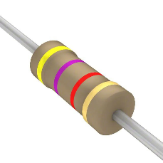

Fig: Resistor

* Quantity: Typically 3 or more (one for each RC stage).
* Purpose: Resistors form part of the RC network, determining the phase shift in combination with capacitors. They help control the frequency of oscillation and stabilize the circuit.

1. **Capacitors (C)**

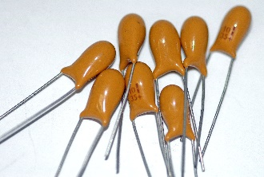

Figure: Capacitor

* Quantity: Typically 3 or more (one for each RC stage).
* Purpose: Capacitors work with resistors in the RC network to provide the necessary phase shift (typically 60° per stage in a three-stage network). The value of the capacitors affects the oscillation frequency.

1. 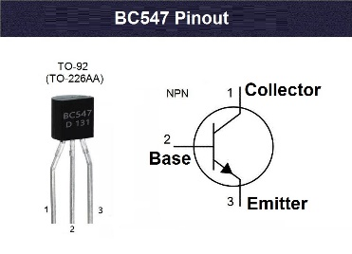**Transistor**

Figure: Transistor

* Type: Transistor or Operational Amplifier (Op-Amp).
* Purpose: The amplifier provides the necessary 180-degree phase shift and amplifies the feedback signal to maintain sustained oscillations.
  + Transistor-Based Design: A transistor, like an NPN (e.g., BC547) or PNP, can be used to amplify the signal and provide the phase shift.
  + Operational Amplifier-Based Design: An operational amplifier (e.g., LM741 or TL081) is often used because of its ease of implementation, stability, and linearity.

**4. Feedback Network** (RC stages)

* Structure: A series of 3 (or more) RC stages connected in cascade.
* Purpose: Each RC stage contributes approximately 60 degrees of phase shift (for a 3-stage network), giving a total of 180 degrees when combined with the inverting amplifier, completing the 360-degree phase shift needed for oscillation.

**5. Power Supply**

* Type: Depending on the amplifier, this could be a DC power supply (commonly between 9V and 15V).
* Purpose: Provides the necessary voltage to power the amplifier (transistor or op-amp).

**6.GENERAL PURPOSE BOARD**

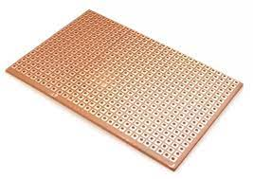

Figure: General purpose board

A "general-purpose board" typically refers to a versatile and flexible platform or board that can be used for a wide range of applications or purposes. These boards are often designed to accommodate various components, modules, and connections, making them suitable for different projects or tasks.

**Chapter 4**

**CALCULATION**

**Practically:**

T=3.7×1m sec

f = 1/3.7×10^-3

**1)A-Network**:

Y1=1.5

Y2=1.8

ɸ= 180- sin^-1[1.5/1.8] = 56.4˚

**2)B Network:**

Y1=2.8

Y2=3

ɸ= 180- sin^-1[2.8/3] = 111˚

**3)C Network:**

Y1=1.9

Y2=0.4

ɸ= 180- sin^-1[0.4/1.9] = 168˚

**THEORETICALLY:**

R= 10KΩ

C=0.1µf

f=1/2πRC

=1/2×3.14×10^3×10×0.1×10^-6

=159.23.

**Chapter 5**

**CIRCUIT DIAGRAM**

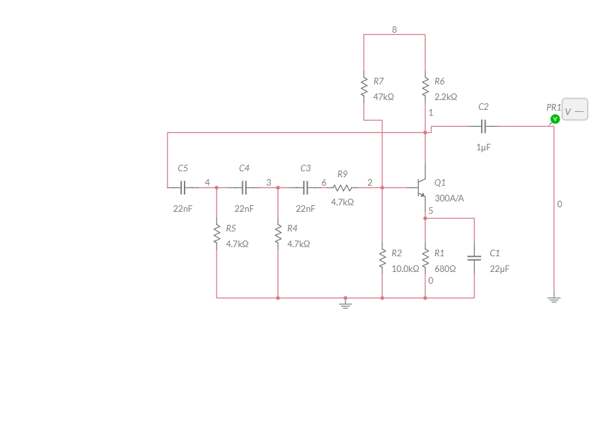

Fig: Circuit Diagram

The RC phase shift oscillator circuit typically consists of three main parts: the amplifier, the feedback network, and the power supply. Here's a step-by-step explanation of its working:

**1. Amplifier Section**

* Component: Transistor or Operational Amplifier (Op-Amp)
* Function: The amplifier is used to amplify the feedback signal and provide a 180-degree phase shift. This is necessary because the RC feedback network also introduces a 180-degree phase shift, and together, they complete the 360-degree phase shift needed for sustained oscillations.

Using a Transistor:

* A common-emitter configuration of an NPN transistor (BC547) is used for amplification. The transistor's collector provides an inverted output signal relative to its input, giving the required 180-degree phase shift.

**2. RC Feedback Network**

* Components: Three resistors and three capacitors (forming three RC stages)
* Function: The feedback network consists of three RC stages that are connected in cascade (one after another). Each stage provides approximately a 60-degree phase shift, totaling 180 degrees for all three stages. This phase shift is frequency-dependent and is crucial for oscillation.

The output of the amplifier is fed into the first RC stage, and the output of the third RC stage is fed back to the input of the amplifier. The feedback is positive because the 180-degree phase shift provided by the RC network, combined with the 180-degree phase shift from the inverting amplifier, gives the required 360-degree phase shift for sustained oscillation.

**3. Power Supply**

* Component: DC power supply
* Function: The power supply provides the necessary voltage for the transistor or op-amp to operate. For a transistor-based design, this could be a single positive voltage (like +9V or +12V). For an op-amp, a dual supply (e.g., +9V and -9V) is often used.

**Detailed Circuit Operation**

1. Amplification:
   * The amplifier (either the transistor or op-amp) amplifies the signal and provides a 180-degree phase shift at its output. This is crucial to ensure that the feedback signal is properly inverted.
2. Phase Shift in the RC Network:
   * The signal from the amplifier's output passes through the three RC stages. Each RC stage contributes a phase shift of approximately 60 degrees (for a total of 180 degrees). The frequency of oscillation is determined by the values of the resistors and capacitors used in this RC network.

**RESULT**

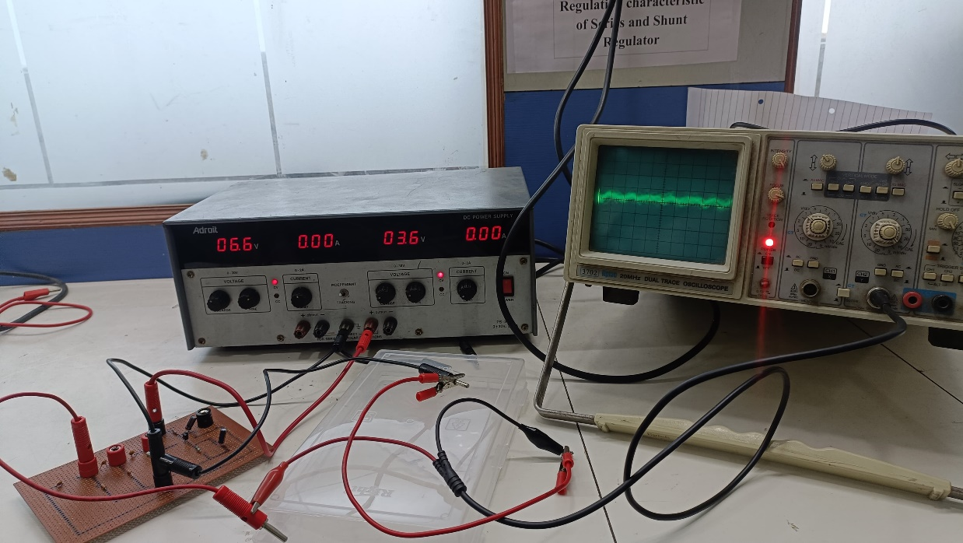

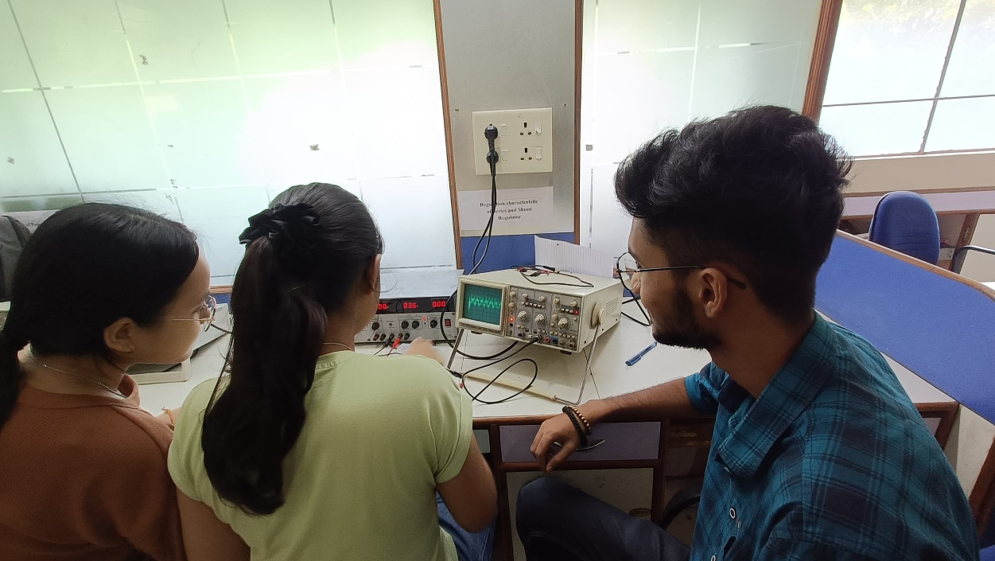

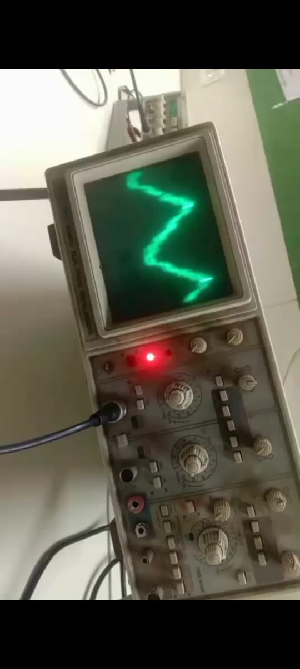

**Chapter 6**

**OUTCOME**

The outcomes of an RC phase shift oscillator primarily relate to the characteristics of the sinusoidal waveform it generates and the performance of the circuit. Here are the key outcomes:

**1. Sinusoidal Output Signal**

* The RC phase shift oscillator generates a continuous sinusoidal waveform at a specific frequency. This is the primary desired outcome of the circuit.

**2.Oscillation Frequency**

The oscillator produces a signal at a predictable frequency based on the component values. The accuracy and stability of the oscillation frequency depend on the stability of the resistors and capacitors used.

**3. Phase Shift**

* The RC network provides a total of 180° phase shift. In a 3-stage RC network, each stage shifts the phase of the signal by approximately 60°, totaling 180° across all stages. This, combined with the 180° phase shift from the inverting amplifier, satisfies the Barkhausen criterion for sustained oscillation (360° or 0° phase shift in total).

**4. Gain Stability**

* The amplifier gain must be set correctly to maintain oscillations. The circuit must have a loop gain of exactly 1 to sustain steady oscillations. If the gain is too high, the output waveform may become distorted. If the gain is too low, oscillations will not start or will die out.

**5. Amplitude of the Output Signal**

* The amplitude of the sinusoidal output depends on the amplifier's gain and the feedback network. In practice, the amplitude stabilizes at a level where the gain of the amplifier is exactly 1.

Successful mapping with CO5 (Course Outcome) of our subject “Signals & System”:

**COURSE OUTCOME (CO5):** Design various oscillator circuits using BJT.

**Chapter 7**

**CONCLUSION**

The **RC phase shift oscillator** is a widely used and fundamental circuit in electronics, designed to generate stable, low-frequency sinusoidal waveforms. Its simplicity, cost-effectiveness, and reliability make it an attractive choice for applications such as audio signal generation, testing instruments, and waveform generation in low-frequency domains.

The oscillator operates by combining an inverting amplifier with a feedback network of resistors and capacitors that create the required 180-degree phase shift, meeting the **Barkhausen criterion** for sustained oscillations. The frequency of oscillation is determined by the values of the resistors and capacitors, offering flexibility in design while maintaining low distortion and stable oscillations.

While the RC phase shift oscillator is easy to design and build, it is generally limited to low-frequency ranges due to the nature of the RC network. It may experience some frequency drift over time due to component tolerances and temperature changes, but using precision components can help improve its stability.

Overall, the RC phase shift oscillator remains a practical and efficient solution for generating sinusoidal waveforms in various electronic applications, especially where simplicity, low cost, and low-frequency operation are desired.

**Chapter 8**

**REFERENCE**

* Electronic Devices and Circuits – David A. Bell
* <https://www.circuitstoday.com/>
* <https://www.electronics-tutorials.ws/>
* <https://github.com/>